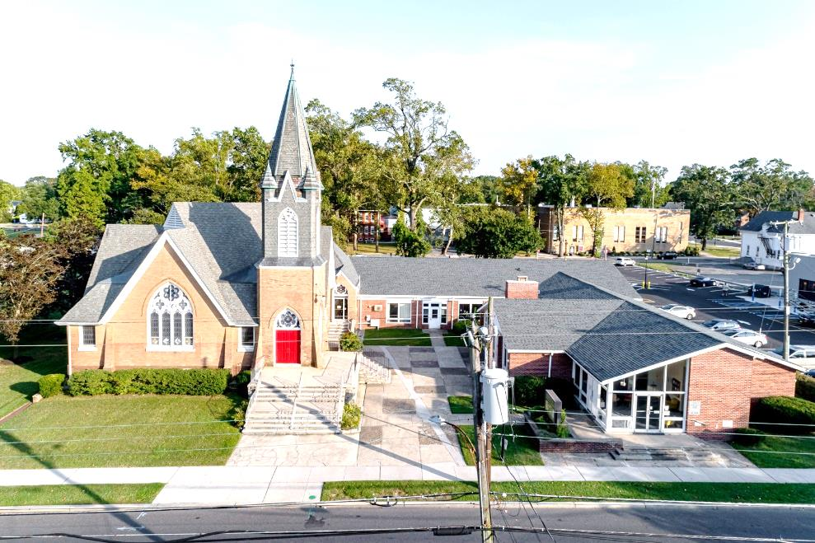

The Presbyterian Church at Hammonton
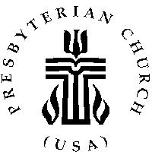

Our vision is to open our doors to all seeking a spiritual home of worship and to carry the light and love of Jesus Christ, our Savior, throughout the community.

MISSION STATEMENT
We are committed to Jesus Christ and the growing of his Church by glorifying God and by proclaiming the good news of the gospel through word and deed. We involve and reach out to our members and our community in Christ’s name through worship, Christian Education, and stewardship to support the mission of our church.

Note: Special thanks to Rev. Paul Grenier for leading us in worship today.

Organist: Cindy Birnbaum
Sunday School Superintendent: Beth Burkett-Rice

2022 2023 2024
ELDERS
Eric Copenhaver Dorrine Esposito Sallye Hershman
Marylee Kondrach Richard Walker Paul Moul
Charles Muller Johanna Johnson

DEACONS
Elsie Bakley Wendy Copenhaver Hilda Lugo
Nancy Foster Ann DiMeo Carol Orsi
Margaret Jones Rebecca Lindstrom Rebecca Villani

Clerk of Session: Beth Burkett-Rice

Church Office: 326 Bellevue Avenue, Hammonton, NJ
Office hours: Tuesday - Thursday 9:30 AM to 12:30 PM
Phone (609) 561-0168 ~ Fax (609) 561-6105
e-mail: office@hammontonpres.org
website: www.hammontonpres.org

THE CELEBRATION OF WORSHIP
NOVEMBER 13TH, 2022
VETERAN’S DAY SERVICE
23RD SUNDAY AFTER PENTECOST
VIRTUAL & LIVE SERVICE
11:00am
****************************************************
~ GATHERING IN GOD’S NAME ~
“Welcome to the Presbyterian Church at Hammonton, we are glad you are able to join us. As we gather for worship feel free to pray and meditate on God’s calling in your life. Be respectful of others around you who might be doing the same, prior and during the Prelude, keeping your voice and conversation soft and to a minimum.”
PRELUDE ~“I Love to Tell the Story”- L. Warriner
“Enter His Courts with Praise” – A. Mason
“Christ, the Sure Foundation”- T. Birchwood

~ TIME FOR CENTERING STILLNESS AND SILENCE ~

WELCOME AND ANNOUNCEMENTS

*THE PEACE
Let the people greet one another by staying in their seats and saying: “Peace be with you!”

INTROIT
~ HUMBLY APPROACHING GOD ~

OPENING POEM: “In Flander’s Fields” by John McCrae
Read by Frank Johnson
* CALL TO WORSHIP
One: The Lord is about to create new heavens and a new earth.
All: We will be glad and rejoice in what God is creating.
One: No more shall the sound of weeping be heard, or the cry of distress.
All: Surely God is our salvation; we will trust, and will not be afraid, for the Lord God is our strength and our might; God has become our salvation.
One: We come today to refresh our spirits in doing what is right.
All: We come with joy and thanksgiving to serve our Savior. Let us worship God.

*HYMN #562 ~ “Eternal Father, Strong to Save”

CALL TO CONFESSION

PRAYER OF CONFESSION (unison) (www.praywithconfidence.com)
O’ God, we confess our failure to love you with all our heart, soul, mind, and strength. We confess our failure to love our neighbor as we love ourselves. We confess our stubborn, judgmental, critical spirits, our prejudice, our pride, and our sinful ways. Forgive us, we pray.
Our nation is in an uproar and we are utterly dependent on You, God, for we have already proved we cannot bring peace and unity with words, protests, violence, or legislation. Our eyes are on you for answers and healing.
Direct the hearts of leaders at every level, whether governmental, community or church, as you direct channels of water. Move their hearts to make godly decisions even if they are not godly people.
We ask you to cleanse our hearts of anything that is not pleasing to You, especially prejudice and a divisive spirit. Help us turn from our old ways of division and injustice and choose righteousness.
Bring us to common ground where we can celebrate both our similarities and our differences in a spirit of unity. Fill us with love for those most like us and for those who are least like us. Bring healing to our land. Bring the peace that passes all understanding. Help us to do justice, love mercy, and walk humbly with you. Begin with me and help me to share Your peace, Your love, Your healing to all I meet.
In the powerful name of Jesus, Amen. (silent confession)
ASSURANCE OF FORGIVENESS

*GLORIA PATRI

ANTHEM~ “This I Pray”

CHILDREN’S MESSAGE

~ RECEIVING GOD’S WORD ~

PRAYER OF ILLUMINATION

SCRIPTURE READINGS Luke 21:5-19 (NT, page 80)
Romans 13:1-9 (NT, 152)

MESSAGE ~ “God and Country”
- Rev. Paul Grenier

~ RESPONDING TO THE WORD ~

*HYMN #543 ~“Abide With Me”

*SAYING WHAT WE BELIEVE

JOYS AND CONCERNS OF THE CHURCH

PASTORAL PRAYER & LORD’S PRAYER
Our Father, who art in heaven, hallowed be Thy name. Thy kingdom come, thy will be done, on earth as it is in heaven. Give us this day our daily bread; and forgive our debts as we forgive our debtors; and lead us not into temptation, but deliver us from evil. For Thine is the kingdom and the power and the glory, forever. Amen.

THE OFFERING OF OUR GIFTS AND OURSELVES

OFFERTORY ~ “Sweet Hour of Prayer” -G. Clarke
*DOXOLOGY (#592)
Praise God, from whom all blessings flow; Praise Him, all creatures here below; Praise Him above, ye heavenly host; Praise Father, Son, and Holy Ghost. Amen.

OFFERTORY PRAYER

~ GOING IN GOD’S NAME ~

*HYMN #447~ “Lead On, O King Eternal”

*THE CHARGE AND BENEDICTION

CLOSING POEM: “My Son Jack” By Rudyard Kipling
Read by Rebecca Lindstrom

POSTLUDE~ “God, the Almighty”- G. Davidson

OUR WORSHIP HAS ENDED, LET OUR SERVICE BEGIN

*Signifies stand if comfortable.

Last Week’s Attendance & Offering:
Attendance: 31 people
Offering: $3,239.00
______________________________________________
CHURCH EVENTS
>>>THIS WEEK:
Monday-11/14:
9:00 AM Clothing Closet
-12:00 PM
7:30 PM ESL classes

Tuesday-11/15:
9:00 AM Clothing Closet
-12:00 PM

Wednesday-11/16:
9:00 AM Clothing Closet
-12:00 PM
7:30 PM ESL classes

______________________________________________

>>UPCOMING:
Monday-11/21:
9:00 AM Clothing Closet
-12:00 PM
7:30 PM ESL classes

Tuesday-11/22:
9:00 AM Clothing Closet
-12:00 PM

Wednesday-11/23:
9:00 AM Clothing Closet
-12:00 PM
7:30 PM ESL classes

______________________________________________

BIRTHDAYS:

No birthdays this week.
______________________________________________
ANNIVERSARIES:

November 19 Pedro & Lillian González
November 19 David & Donna Ordille

SERVING YOU TODAY:

Liturgist: Bill Towne

Ushers: Eric Copenhaver, Captain
John Bock
Matthew Hershman
Theresa Stubbe
Ann DiMeo
Becky Villani

**Children’s Church: Beth Burkett
Next week: Dorrine Esposito

